

Assignment 1

DBD281



April 4, 2025

Freerk van den bos

602074

**Contents**

**Table of Tables** 2

**Table of Figures** 2

**Question 1:** 3

**Rule 1: Information rule** 3

**Rule 2: Guaranteed Access rule** 3

**Rule 3: Systematic Treatment of Null rule** 3

**Rule 4: Dynamic Online Catalogue Based on the Relational Model rule** 3

**Rule 5: Comprehensive Data Sub-language rule** 3

**Rule 6: View Update rule** 3

**Rule 7: High-level Insert, Update and Delete rule** 3

**Rule 8: Physical Data Independence rule** 3

**Rule 9: Logical Data Independence rule** 4

**Rule 10: Integrity Independence rule** 4

**Rule 11: Distribution Independence rule** 4

**Rule 12: Non-Subversion rule** 4

**Rule 0:** 4

**Question 2:** 4

**Question 3:** 6

**Optimized data Storage:** 6

**Security and Authentication:** 6

**Backup and Recovery:** 7

**Performance Monitoring and Tuning:** 7

**Cloud Support:** 7

**References** 8

# **Table of Tables**

Table 1: Comparison of T-SQL and PL/SQL 5

# **Table of Figures**

Figure 1: T-SQL syntax example (Ganesh, 2024) 5

Figure 2: PL/SQL syntax example (Ganesh, 2024) 6

# **Question 1:**

Dr Codd’s 12 rules serve as reference for what a relational database should be.

## **Rule 1: Information rule**

Rule 1 states that all information stored in a relational database should be represented logically as column values in rows within tables (Coronel, et al., 2020).

## **Rule 2: Guaranteed Access rule**

Rule 2 states that every value stored in a table in the database is guaranteed to be accessible through table name, primary key and column name combinations (ibid).

## **Rule 3: Systematic Treatment of Null rule**

Rule 3 states that the value of Null must be treated and represented in a systematic treatment way, independent of data type (Coronel, et al., 2020).

## **Rule 4: Dynamic Online Catalogue Based on the Relational Model rule**

Rule 4 states that metadata must be stored and managed the same way ordinary data are stored and managed, meaning that metadata must be stored in tables within the database. Furthermore, the rule states that this data should be available for authorized users, using the standard databases relational language (ibid).

## **Rule 5: Comprehensive Data Sub-language rule**

Rule 5 states that a relational database can support multiple languages, but they must support one well-defined declarative language which supports data definition, view definition and data manipulation, etc. (Coronel, et al., 2020).

## **Rule 6: View Update rule**

Rule 6 states that any view that is updateable in theory must be updatable throughout the entire system (ibid).

## **Rule 7: High-level Insert, Update and Delete rule**

Rule 7 states that the database must support high-level inserts, updates, and deletes (Coronel, et al., 2020).

## **Rule 8: Physical Data Independence rule**

Rule 8 states that application programs are logically unaffected when physical changes are made to the database (ibid).

## **Rule 9: Logical Data Independence rule**

Rule 9 states that application programs are logically unaffected when changes are made to the table structures in the database that do not change the original table values (Coronel, et al., 2020).

## **Rule 10: Integrity Independence rule**

Rule 10 states that all the relational integrity constraints must be defined in the relational language and stored in the system catalogue and not in the application layer (ibid).

## **Rule 11: Distribution Independence rule**

Rule 11 states that the end user and application programs must be unaware of and unaffected by the location of the data (Coronel, et al., 2020).

## **Rule 12: Non-Subversion rule**

Rule 12 states that the integrity rules of the database must be able to be bypassed in a way if the system supports low-level data access (ibid).

## **Rule 0:**

Rule 0 states that the rules are based on the concept for a database to be relational, it must use its relational facilities to manage the database (Coronel, et al., 2020).

# **Question 2:**

* Transact-SQL (T-SQL) is an implementation of SQL for Microsoft’s SQL Server (Kellenberger & Everest, 2020).
* PL/SQL is an implementation of SQL for Oracle relational databases (Secure Flag, 2022).

|  |  |  |
| --- | --- | --- |
| Feature | T-SQL | PL/SQL |
| Syntax | Uses the “DECLARE” keyword for variable declaration, “BEGIN…END” for blocks and “IF…ELSE” for conditions (Ganesh, 2024). | Uses the “DECLARE” keyword for variable declaration, “IS” or “AS” for blocks and “IF…ELSID…ELSE” for conditions (Ganesh, 2024). |
| Error Handling | Uses the “TRY…CATCH” keyword (Ganesh, 2024). | Uses the “EXCEPTION” keyword (Ganesh, 2024). |
| Cursors | Supports cursors for looping through results (Ganesh, 2024). | Supports cursors for looping through results but provide additional advanced features (Ganesh, 2024). |
| Indexing | Allows only for Index Partitioning and not Bitmap Indexes or Partitioned Indexes (Dwivedi, 2024). | Allows Partitioned Indexes, Bitmap Indexes (Dwivedi, 2024). |
| Transaction Controle | Each change is committed individually and is difficult to roll back any changes, unless enclosed by the “BEGIN TRANSACTION” keyword (Dwivedi, 2024). | Each connection to the database is a new transaction, until the command “COMMIT” is used each change is only stored in memory, it is easier to roll back on any changes (Dwivedi, 2024) |

Table : Comparison of T-SQL and PL/SQL

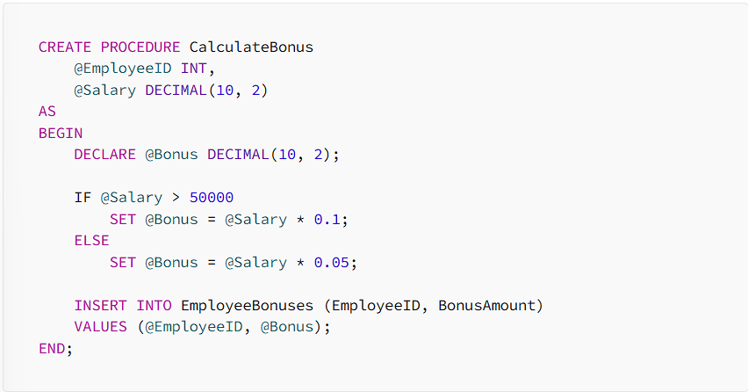

Figure : T-SQL syntax example (Ganesh, 2024)

Figure : PL/SQL syntax example (Ganesh, 2024)

# **Question 3:**

## **Optimized data Storage:**

Microsoft SQL Server provides users with Memory-optimized tables that are atomic, consistent, isolated, and durable (ACID) (Microsoft, 2024). Microsoft added a feature called Hybrid buffer pool to SQL Server 2019 and enhanced it with the SQL Server 2022 release, this feature enabled the buffer pool objects to reference data pages on persistent memory (PMEM) rather than fetching copies of the data pages from disks and caching them in volatile memory (Microsoft, 2023).

## **Security and Authentication:**

Microsoft implemented a feature called Ledger that provides a database with tamper-evidence capabilities (Microsoft, 2025). Ledger protects data from attackers or high-privileged users such as database administrators by protecting historical data (Microsoft, 2024). Another feature that provides security for SQL Server databases are Microsoft Entra authentication that uses authentication with Microsoft Entra ID to connect the user to the SQL Server (Microsoft, 2025). SQL Server 2019 and later versions are also equipped with what Microsoft calls Always Encrypted with enclaves, this feature protects sensitive data in the database from any user that has access to the database but are restricted to access certain data, the data is encrypted on the client side and the data in plain text and the cryptographic key is never stored in the in the database engine (Microsoft, 2025).

## **Backup and Recovery:**

SQL Server 2022 can be backed up to S3-compatible object storage (Nocentino, 2023). S3 or an Amazon S3 bucket is a cloud storage solution offered in Amazon Web Service (AWS) Simple Storage Service platform (Yasar, n.d.).

Accelerated Database Recovery (ADR) improves scalability and efficiency that can lead to faster recovery times during backup and recovery processes (Microsoft, 2025).

## **Performance Monitoring and Tuning:**

SQL Server 2022 have improved intelligent query processing features, allowing users to use a variety of queries without needing to change any code in the database (Microsoft, 2025). Furthermore, the query store feature can read replicas in the database enhancing the overall performance monitoring and tuning capabilities of SQL Server (ibid).

## **Cloud Support:**

Microsoft extended the Azure connection with SQL Server 2022 some new features include Azure Synapse Link, allowing SQL Server 2022 to be integrated with Azure Synapse Analytics this enables for quick analytics of data (Microsoft, 2024).

SQL Server also allows Bidirectional Transactional Replication between SQL Server and Azure SQL Managed Instance to enhance the transfer of data into the cloud (Microsoft, 2025).

# **References**

Coronel, C., Morris, S., Crockett, K. & Blewett, C., 2020. *Database Principles fundamentals of design, implementation, and management.* 3rd ed. Hampshire: ‎Cengage Learning EMEA.

Dwivedi, P., 2024. *Hevo Data.* [Online]   
Available at: https://hevodata.com/learn/t-sql-vs-p-l-sql/?utm_source=chatgpt.com  
[Accessed 03 April 2025].

Ganesh, R., 2024. *Medium.* [Online]   
Available at: https://medium.com/%40rganesh0203/t-sql-vs-pl-sql-6e938b8da0da  
[Accessed 03 April 2025].

Kellenberger, K. & Everest, L., 2020. *Beginning T-SQL A Step-by-Step Approach.* 4th ed. s.l.:Apress.

Microsoft, 2023. *Microsoft.* [Online]   
Available at: https://learn.microsoft.com/en-us/sql/database-engine/configure-windows/hybrid-buffer-pool?view=sql-server-ver16#hybrid-buffer-pool-with-direct-write  
[Accessed 3 April 2025].

Microsoft, 2024. *Microsoft.* [Online]   
Available at: https://learn.microsoft.com/en-us/sql/relational-databases/security/ledger/ledger-overview?view=sql-server-ver16  
[Accessed 3 April 2025].

Microsoft, 2024. *Microsoft.* [Online]   
Available at: https://learn.microsoft.com/en-us/sql/relational-databases/in-memory-oltp/introduction-to-memory-optimized-tables?view=sql-server-ver16  
[Accessed 3 April 2025].

Microsoft, 2024. *Microsoft.* [Online]   
Available at: https://learn.microsoft.com/en-us/sql/sql-server/editions-and-components-of-sql-server-2022?view=sql-server-ver16&utm_source=chatgpt.com  
[Accessed 3 April 2025].

Microsoft, 2025. *Microsoft.* [Online]   
Available at: https://learn.microsoft.com/en-us/sql/sql-server/what-s-new-in-sql-server-2022?view=sql-server-ver16&utm_source=chatgpt.com  
[Accessed 03 April 2025].

Microsoft, 2025. *Microsoft.* [Online]   
Available at: https://learn.microsoft.com/en-us/sql/relational-databases/security/encryption/always-encrypted-enclaves?view=sql-server-ver16  
[Accessed 3 April 2025].

Nocentino, A., 2023. *Pure Storage.* [Online]   
Available at: https://www.purestorage.com/au/video/webinars/using-sql-server-2022-new-storage-features/6343522098112.html?utm_source=chatgpt.com  
[Accessed 3 April 2025].

Secure Flag, 2022. *Secure Flag.* [Online]   
Available at: https://blog.secureflag.com/2022/04/05/pl-sql-and-t-sql-pros-cons-and-security-concerns/#:~:text=a%20single%20statement.-,PL%2FSQL%20vs%20T%2DSQL,be%20done%20rather%20than%20how.  
[Accessed 03 April 2025].

Yasar, K., n.d. *Tech Target.* [Online]   
Available at: https://www.techtarget.com/searchaws/definition/AWS-bucket#:~:text=An%20Amazon%20S3%20bucket%20is,called%20objects%20instead%20of%20files.  
[Accessed 3 April 2025].